Nathan Bemus

Homework 1

ECCS 4361.01

9/6/17

Task 1:

I divided the following two images pixel by pixel.

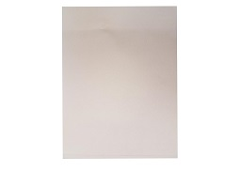 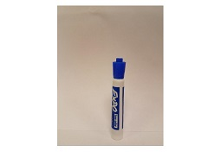

This is the result that occurred with the following Matlab Code.

im=imread('Blank','jpeg');

im1=imread('Marker','jpeg');

im2=double(im1) ./ double(im);

imshow(im2);

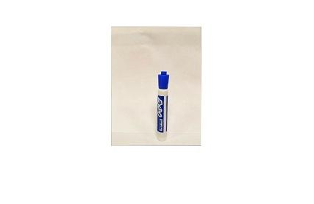

Task 2:

This is the original image that is being edited.



This is the image after being rotated in Matlab with the code.

im3=imrotate(im2,45);

imshow(im3);

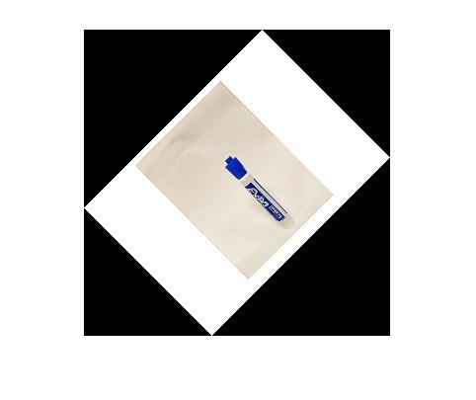

This is the image after being translated 50 pixels with the Matlab code.

im3=imtranslate(im2, [50,50]);

imshow(im3);

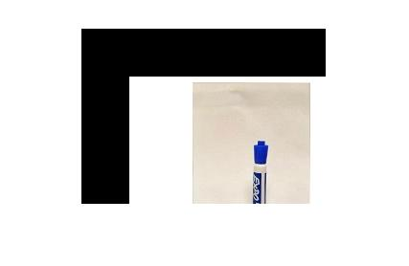

This is the image after being rescaled by 50% with the following Matlab code

im3 = imresize(im2, .5);

imshow(im3);

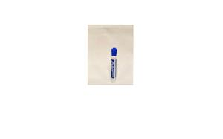

Task 3:

This is the original marker image that is being edited.



With the following Matlab code I was able to change the image above to the following.

clear all;

clc;

itemp = imread('cs.jpg'); %read the image

i = itemp(:,:,1);

i1 = itemp(:,:,2);

rtemp = min(i); % find the min. value of pixels in all the columns (row vector)

rmin = min(rtemp); % find the min. value of pixel in the image

rtemp = max(i); % find the max. value of pixels in all the columns (row vector)

rmax = max(rtemp); % find the max. value of pixel in the image

m = 255/(rmax - rmin); % find the slope of line joining point (0,255) to (rmin,rmax)

c = 255 - m*rmax; % find the intercept of the straight line with the axis

i_new = m*i + c; % transform the image according to new slope

i1_new = m*i1 + c;

figure,imshow(i); % display original image

figure,imshow(i_new); % display transformed image

figure,imshow(i1_new);

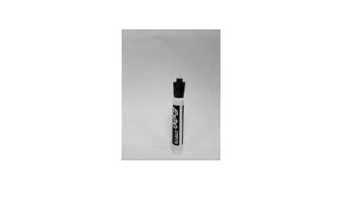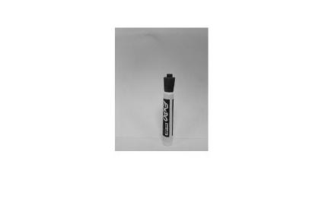

i i_new i1_new